Contest – What feeds your perseverance?
For your class to be eligible for the draw, you must fill out the form below and send it to the Regroupement lavallois pour la réussite éducative along with 2 of your students’ projects (2 projects per participating class). The projects must be submitted by email to the following address: emitogo@cslaval.qc.ca. Deadline is February 25th, 2022. Good luck to all!

Teacher’s name :
Name of school :
Grade level :
Class number if applicable :
Names of students whose projects have been submitted: | A)  B)
Reason for choice of projects (ex.: most persevering students, best drawings, quality of writing, etc.) | A)  B)
Type of project selected (drawing, comic strip, short or long text)

Books read in preparation for the project
(not mandatory):

*Send the two projects, along with this entry form to the following address :
emitogo@cslaval.qc.ca

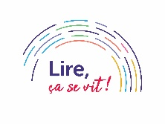
Bonne chance

